Solution Architecture Design Document
Project Name: Smart Fleet Management System
Cloud Provider: Amazon Web Services (AWS)
Architecture Pattern: Event-Driven, Serverless, IoT-based
Document Type: Solution Architecture Design (SAD)

1. Executive Summary
The Smart Fleet Management System is a cloud-native platform designed to provide real-time visibility, operational analytics, and predictive maintenance insights for vehicle fleets. The solution leverages AWS IoT, serverless compute, and analytics services to ingest, process, store, and analyze telemetry data generated by fleet vehicles.
The architecture emphasizes scalability, cost efficiency, security, and low operational overhead, making it suitable for logistics, transportation, and service-based organizations.

2. Business Problem
Fleet operators currently face:
- Limited real-time visibility into vehicle location and health
- Reactive maintenance leading to downtime and increased costs
- Inefficient fuel usage
- Fragmented and unstructured vehicle data
These challenges reduce operational efficiency and increase overall fleet management costs.

3. Business Objectives
- Enable real-time tracking of fleet vehicles
- Automate maintenance alerts based on telemetry data
- Provide historical analytics on fuel consumption and usage
- Support predictive maintenance through data-driven insights
- Centralize fleet data into a single cloud platform

4. Scope
In Scope
- Vehicle telemetry ingestion
- Real-time processing and alerting
- Historical data storage and analytics
- Operational dashboards
- Predictive maintenance (optional)
Out of Scope
- Custom hardware/firmware development
- Physical device manufacturing
- Driver mobile applications

5. High-Level Architecture Overview
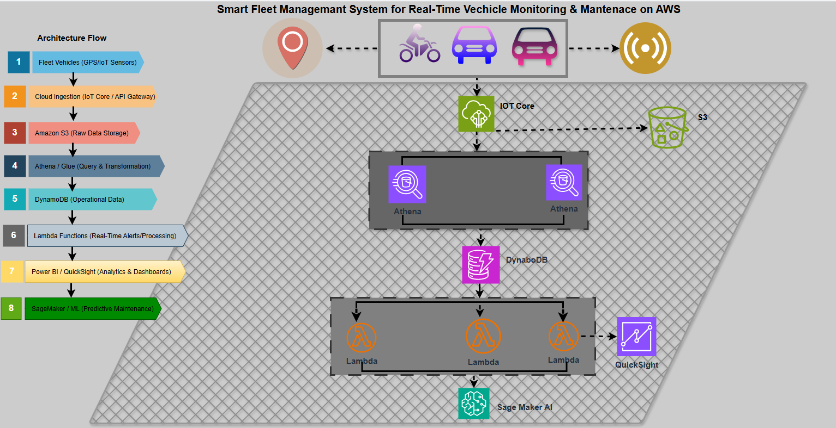
Architecture Flow:
- Vehicles send telemetry data to AWS IoT Core
- IoT Rules route data to S3, Lambda, and DynamoDB
- S3 stores raw historical data
- DynamoDB stores real-time vehicle state
- Athena queries historical data
- BI tools visualize analytics
- Optional ML models predict maintenance needs

6. Architecture Components and Justification
AWS IoT Core
- Secure device ingestion using certificates
- Native MQTT support
- Highly scalable telemetry handling
Amazon S3 (Data Lake)
- Durable, low-cost storage
- Stores raw telemetry for analytics and ML
- Partitioned for efficient Athena queries
AWS Lambda
- Event-driven processing
- Real-time alert generation
- Data validation and enrichment
Amazon DynamoDB
- Low-latency access to live vehicle state
- Scales automatically with fleet size
Amazon Athena
- Serverless SQL analytics on S3
- No infrastructure management required
Power BI / Amazon QuickSight
- Operational dashboards
- Historical trend analysis
Amazon SageMaker
- Predictive maintenance model training
- Failure prediction and optimization

7. Data Design
Telemetry Message Format (JSON)
- Vehicle ID
- Timestamp
- GPS coordinates
- Engine metrics
- Fuel level
- Mileage
S3 Partitioning Strategy
s3://fleet-raw-data/year=/month=/day=/vehicle_id=/
DynamoDB Table
Table Name: FleetVehicleState
Primary Key: vehicle_id
Purpose: Latest state per vehicle

8. Security & Governance
- IAM roles with least-privilege access
- TLS encryption for IoT communication
- Encryption at rest (S3, DynamoDB)
- CloudWatch logging and monitoring

9. Scalability & Performance
- Fully serverless architecture
- Automatic scaling across ingestion, compute, and storage
- Designed to handle thousands of vehicles concurrently

10. Cost Considerations
- Pay-per-use services (Lambda, Athena)
- S3 lifecycle policies for cost optimization
- DynamoDB on-demand capacity

11. Risks and Trade-Offs
Decision | Trade-Off
Serverless | Less control, lower ops burden
DynamoDB | No complex joins
Athena | Batch, not real-time

12. Compliance Alignment
- GDPR-ready architecture
- Secure data handling and access controls
- Auditability via CloudTrail

13. Conclusion
This solution provides a scalable, secure, and cost-efficient fleet management platform aligned with modern cloud and IoT best practices.

